Tentative Payment Date Predictor

Submitted in partial fulfillment of the requirements for the award of degree of

**BACHELOR** **OF ENGINEERING IN**

**COMPUTER SCIENCE & ENGINEERING**



**Submitted to: Submitted By:**

**SHIVAM – 18BCS3054**

**Mentor Signature**

**DEPARTMENT OF COMPUTER SCIENCE & ENGINEERING**

# Chandigarh University, Gharuan

**2022**

# Implementation

Steps to predict date for invoice payment

1. Import libraries
2. Read the dataset
3. Analyze the invoice generation and payment close dates
4. Sort the dataset on date time and filter “Date” and “Close” columns
5. Normalize the new filtered dataset and Apply EDA on the dataset
6. Build and train the LSTM model
7. Take a sample of a dataset to make stock price predictions using the LSTM model
8. Prepare test dataset
9. Data Visualization

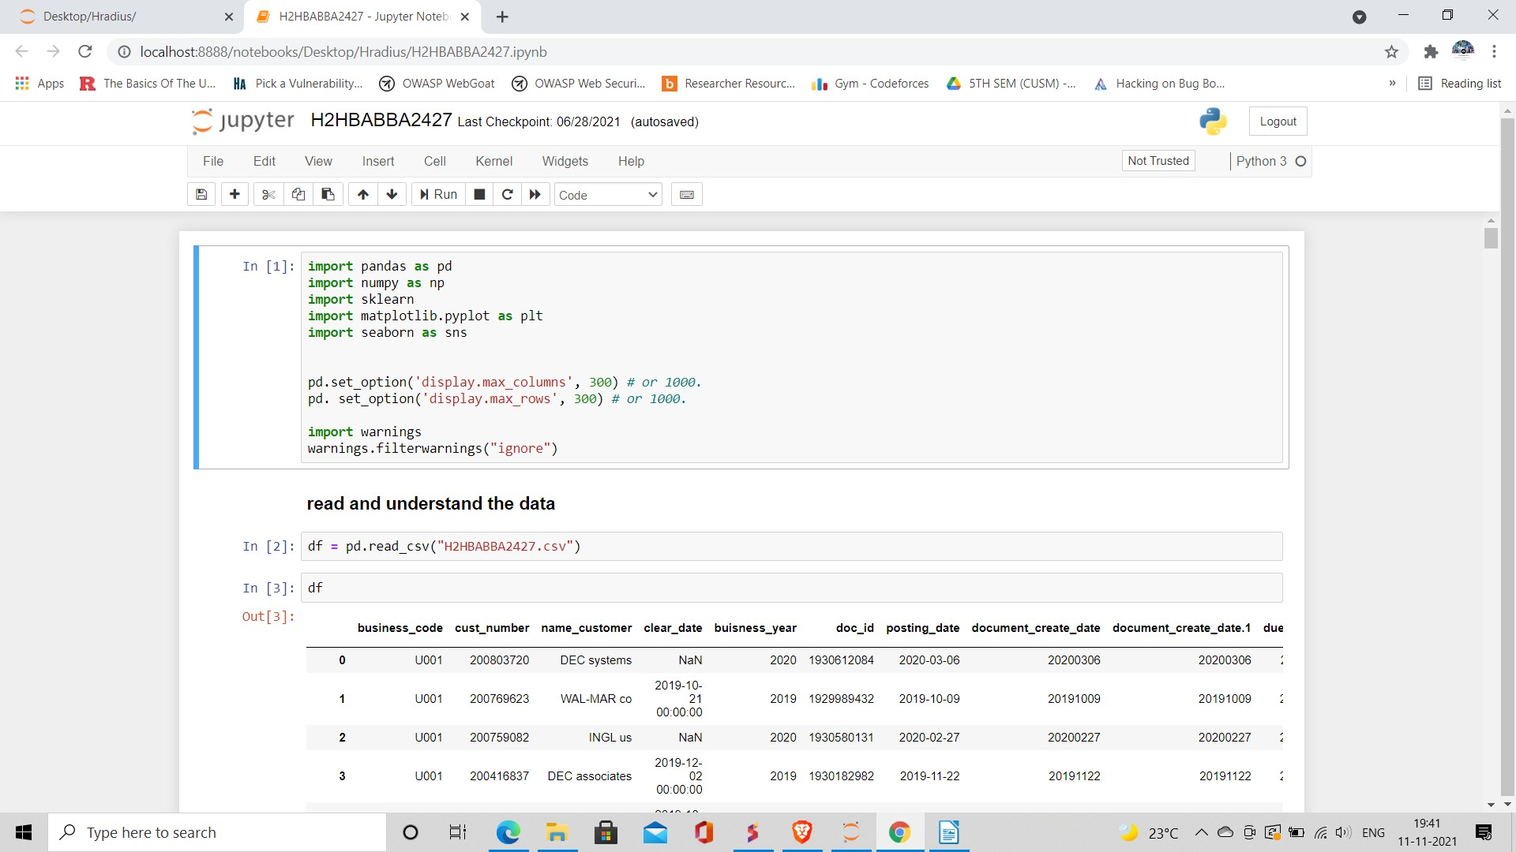

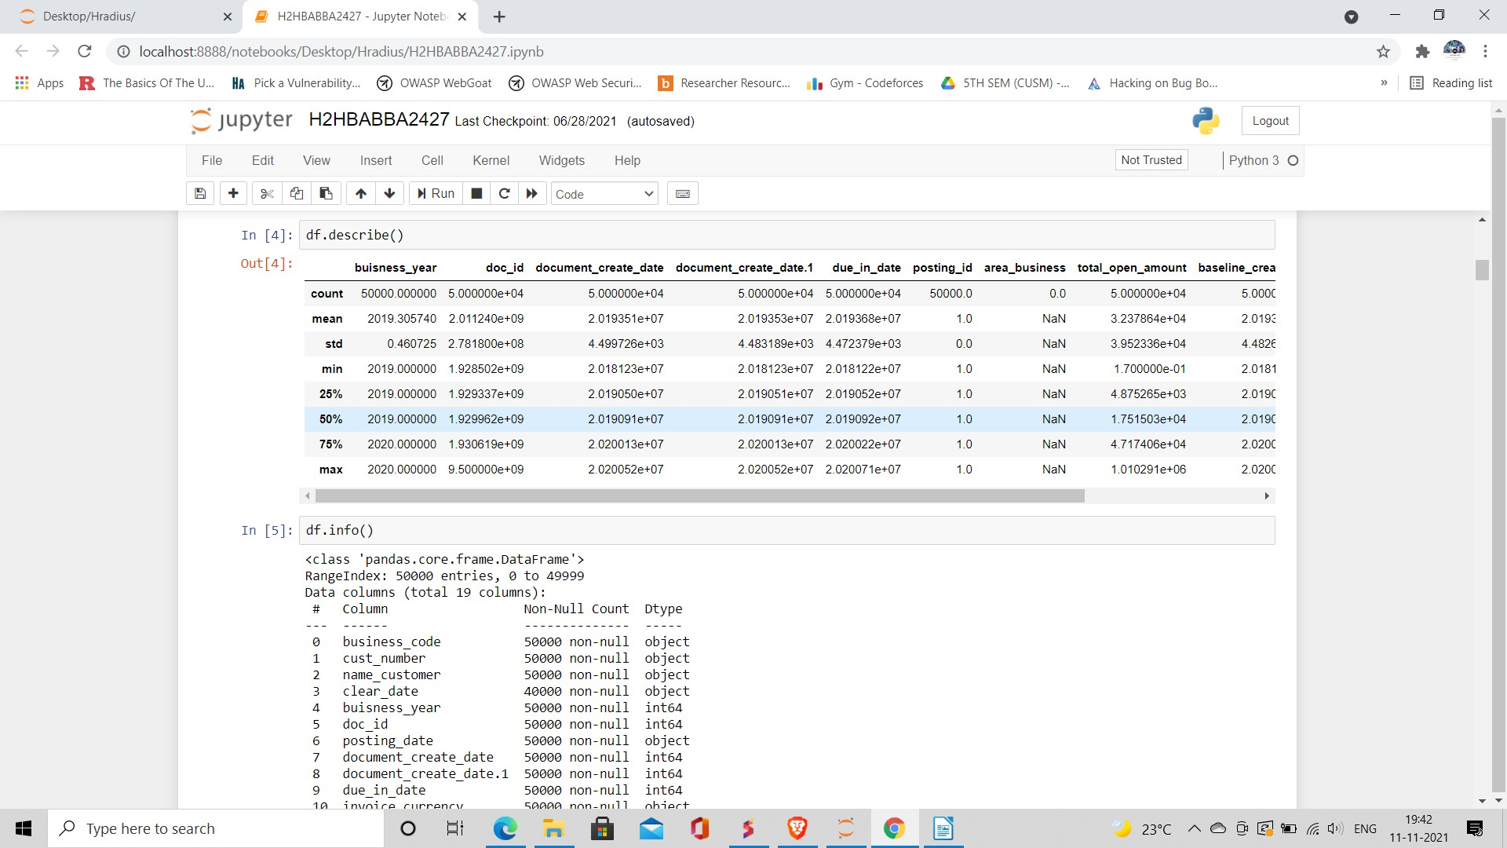

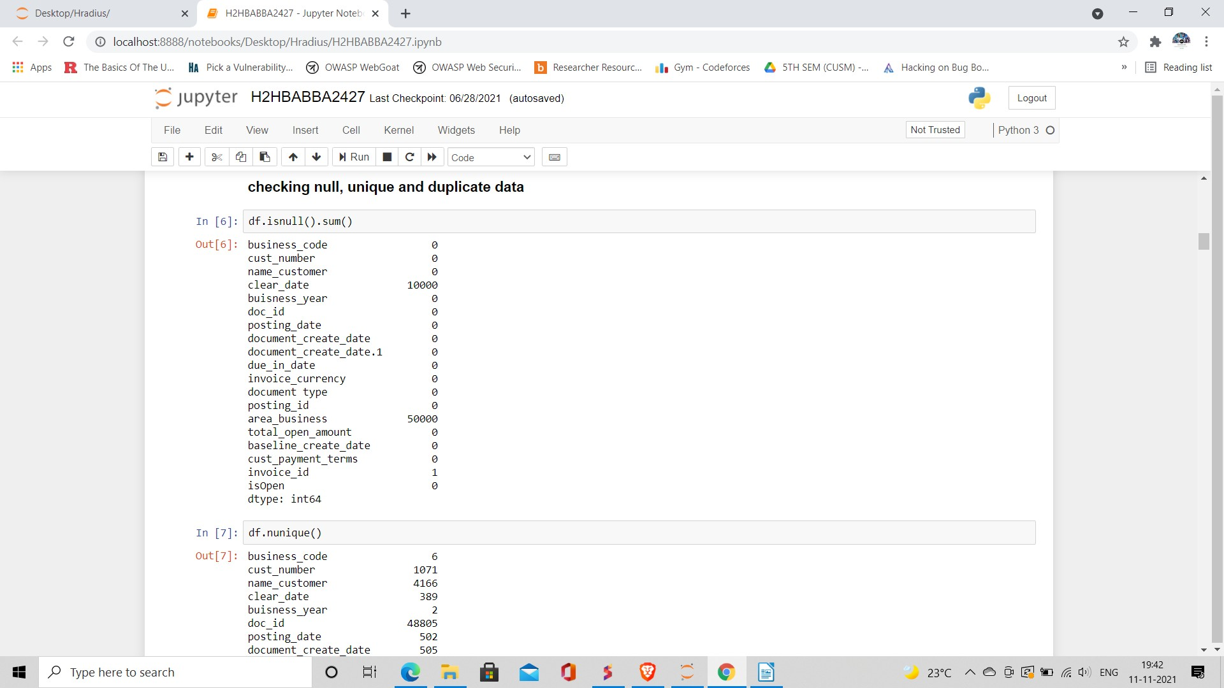

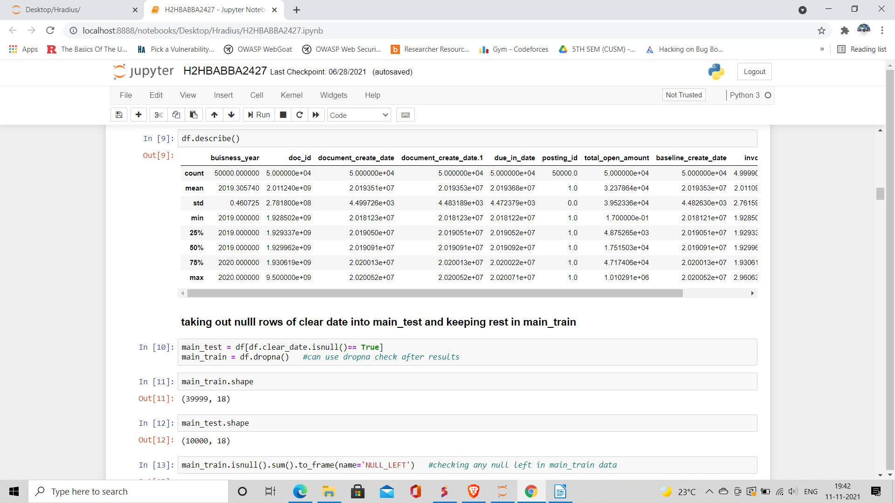

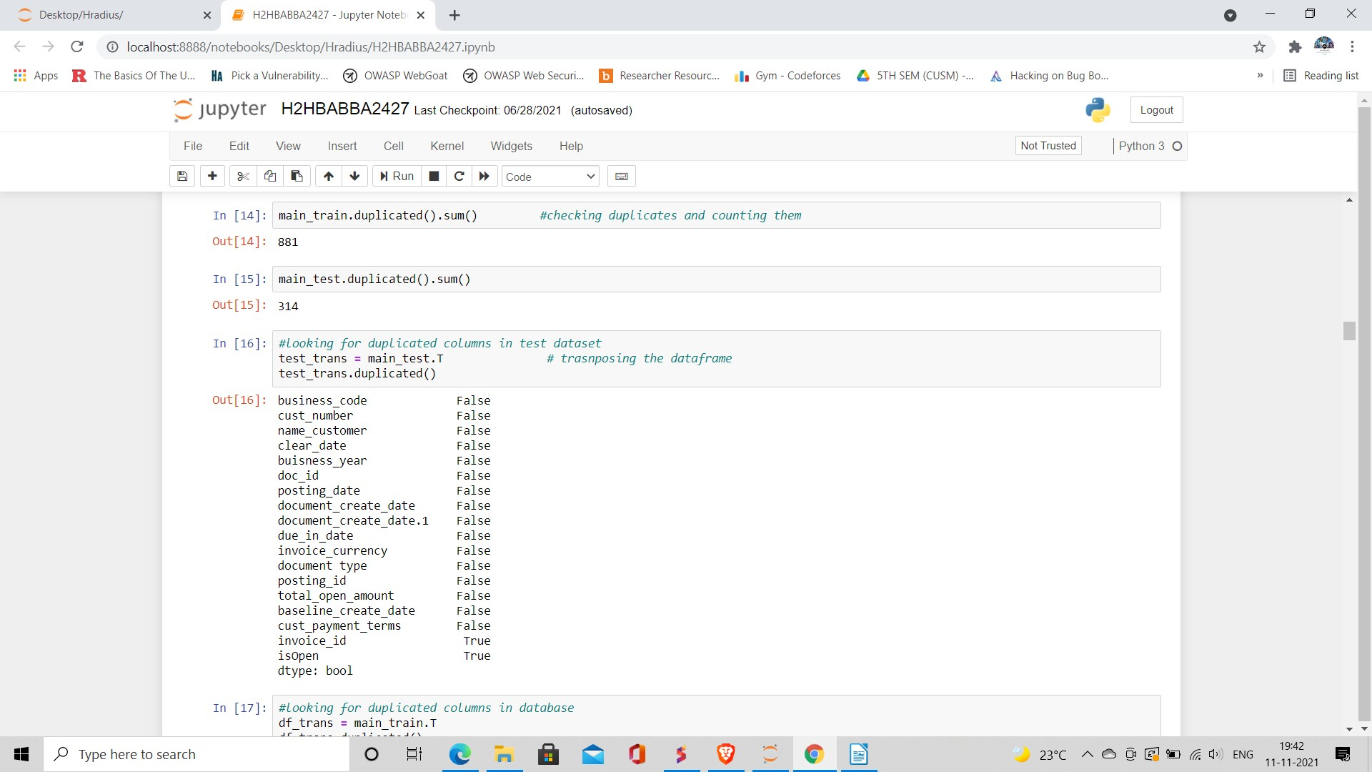

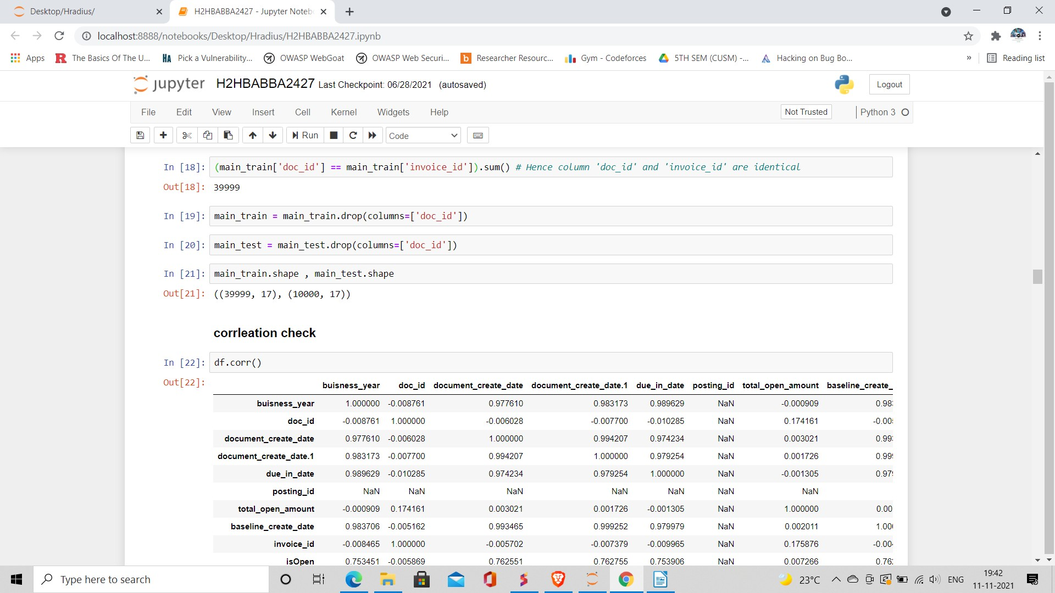

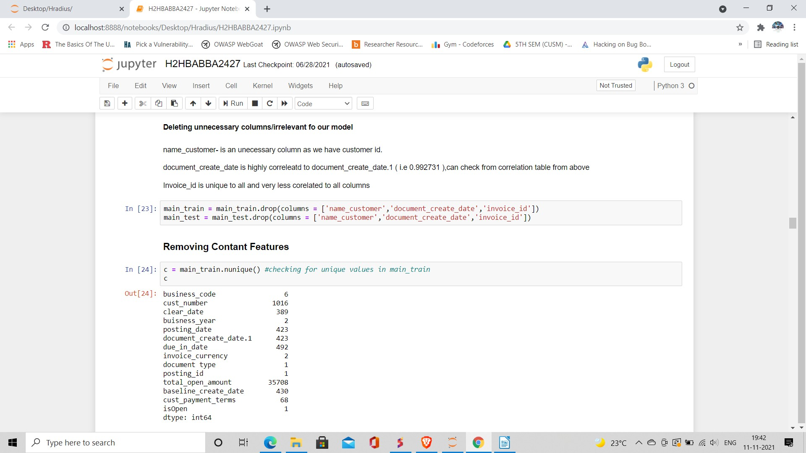

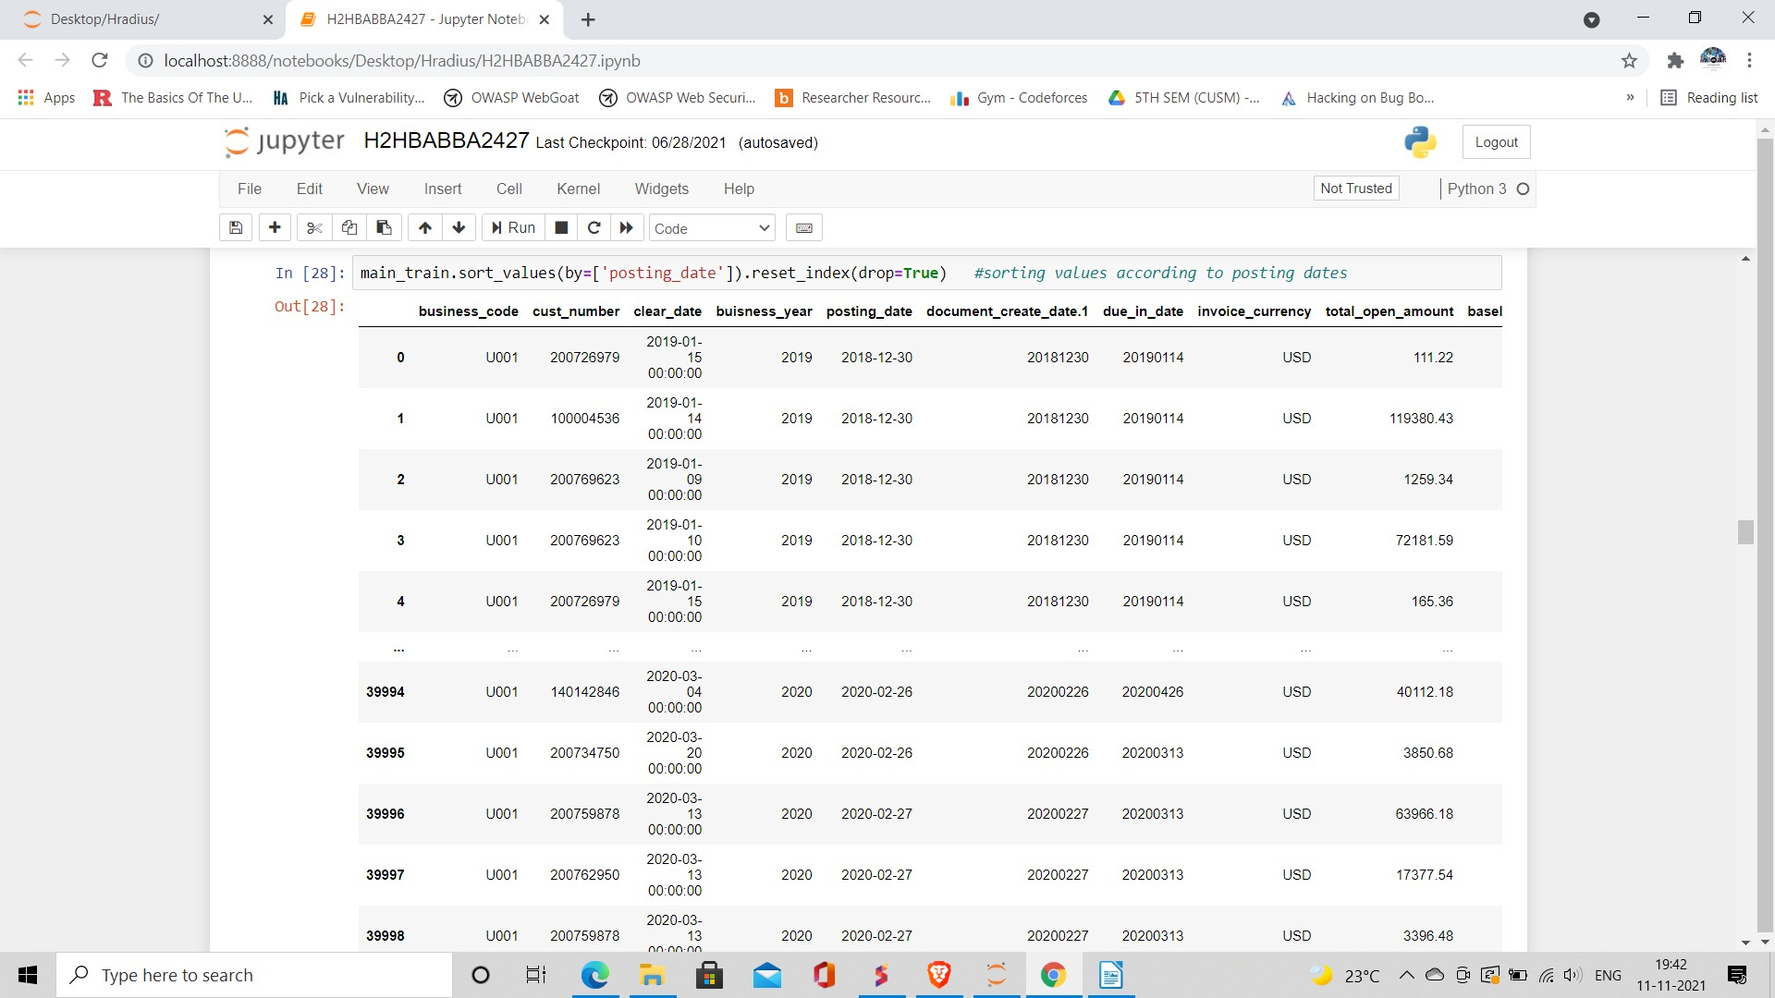

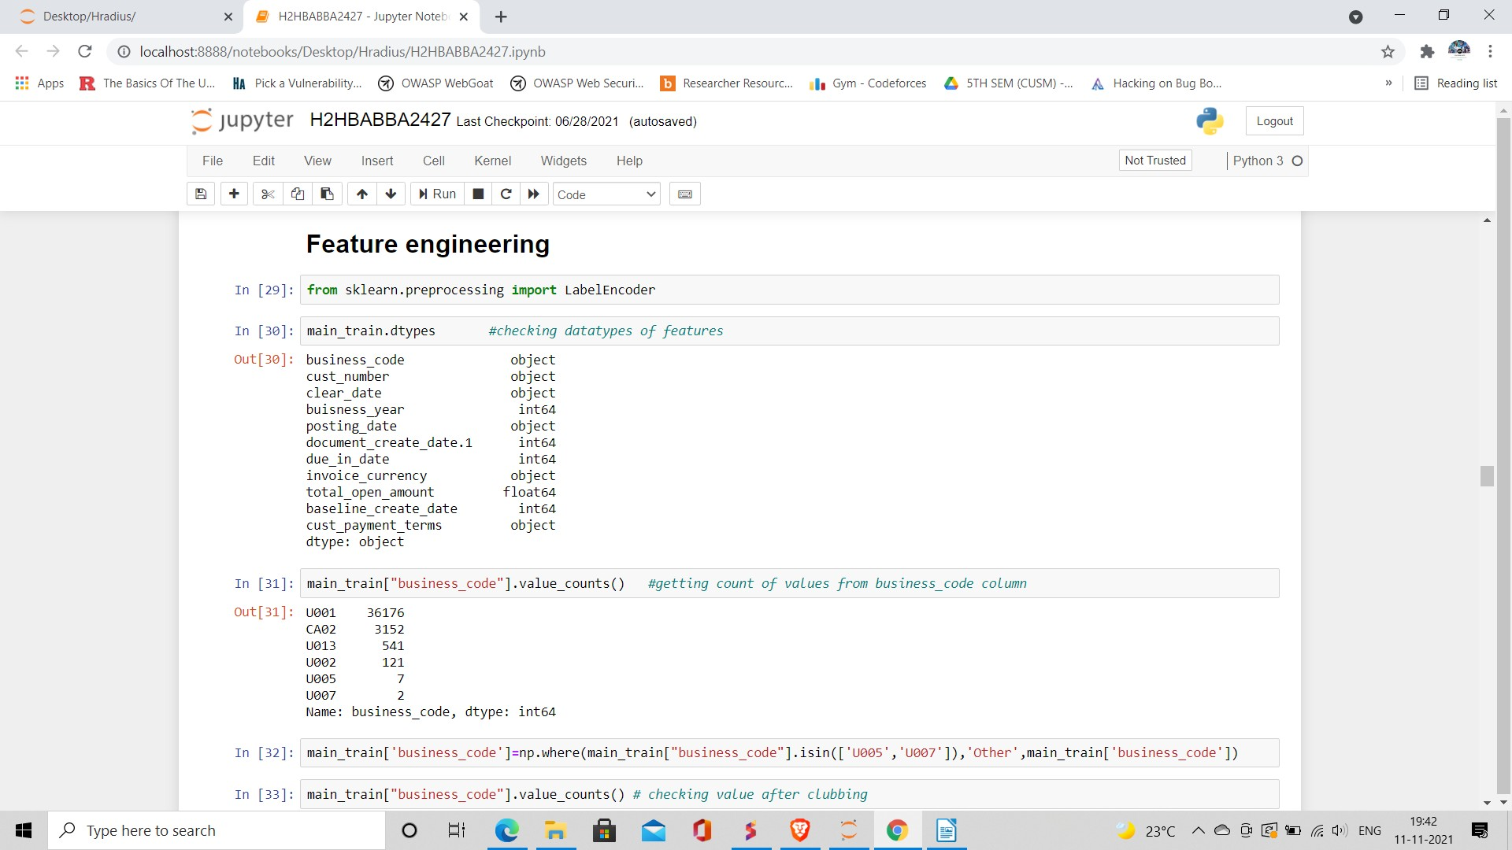

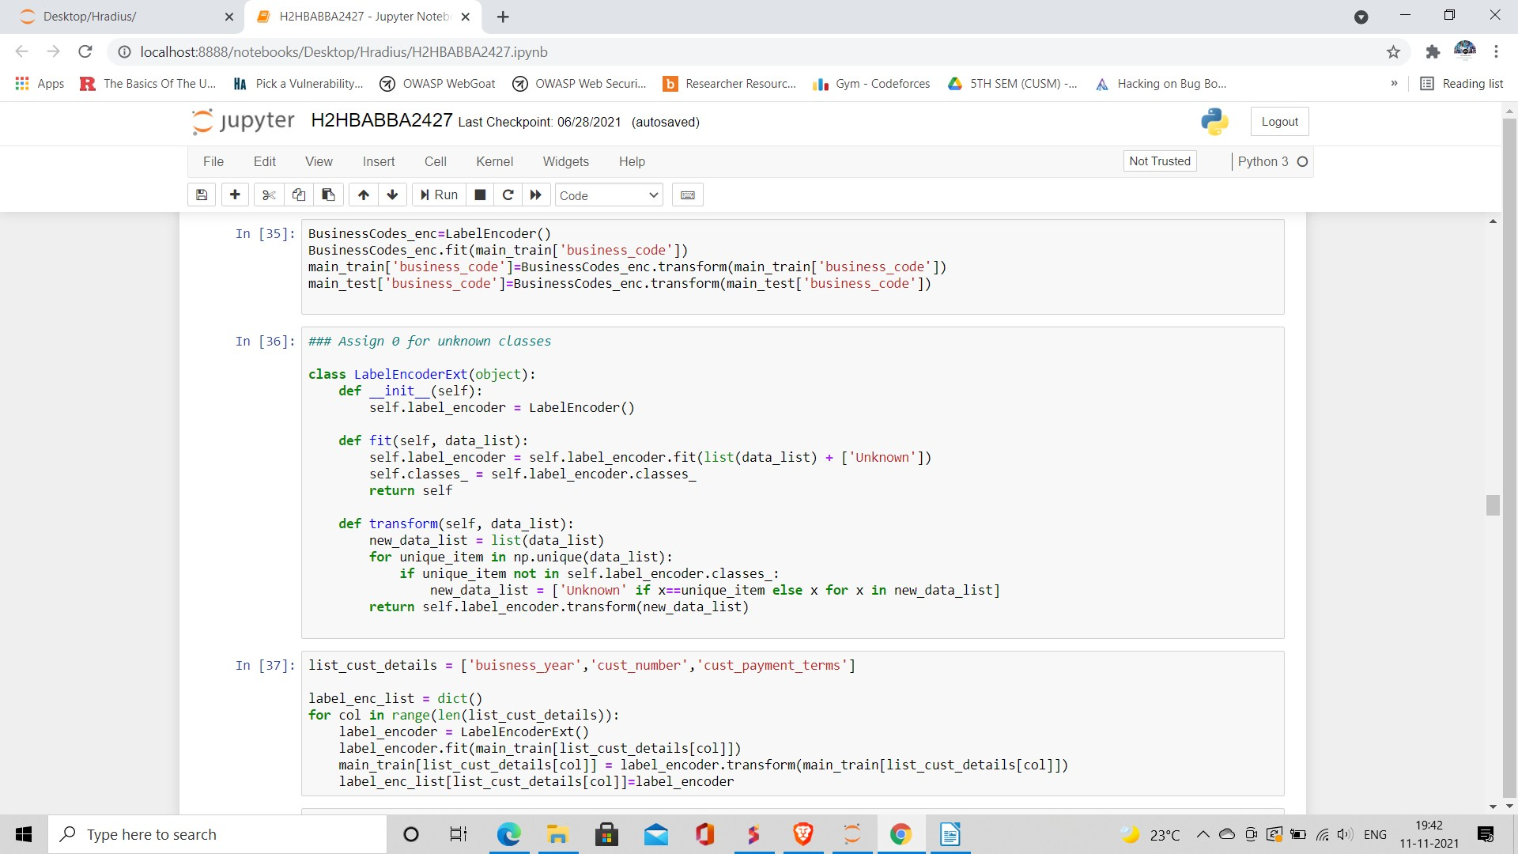

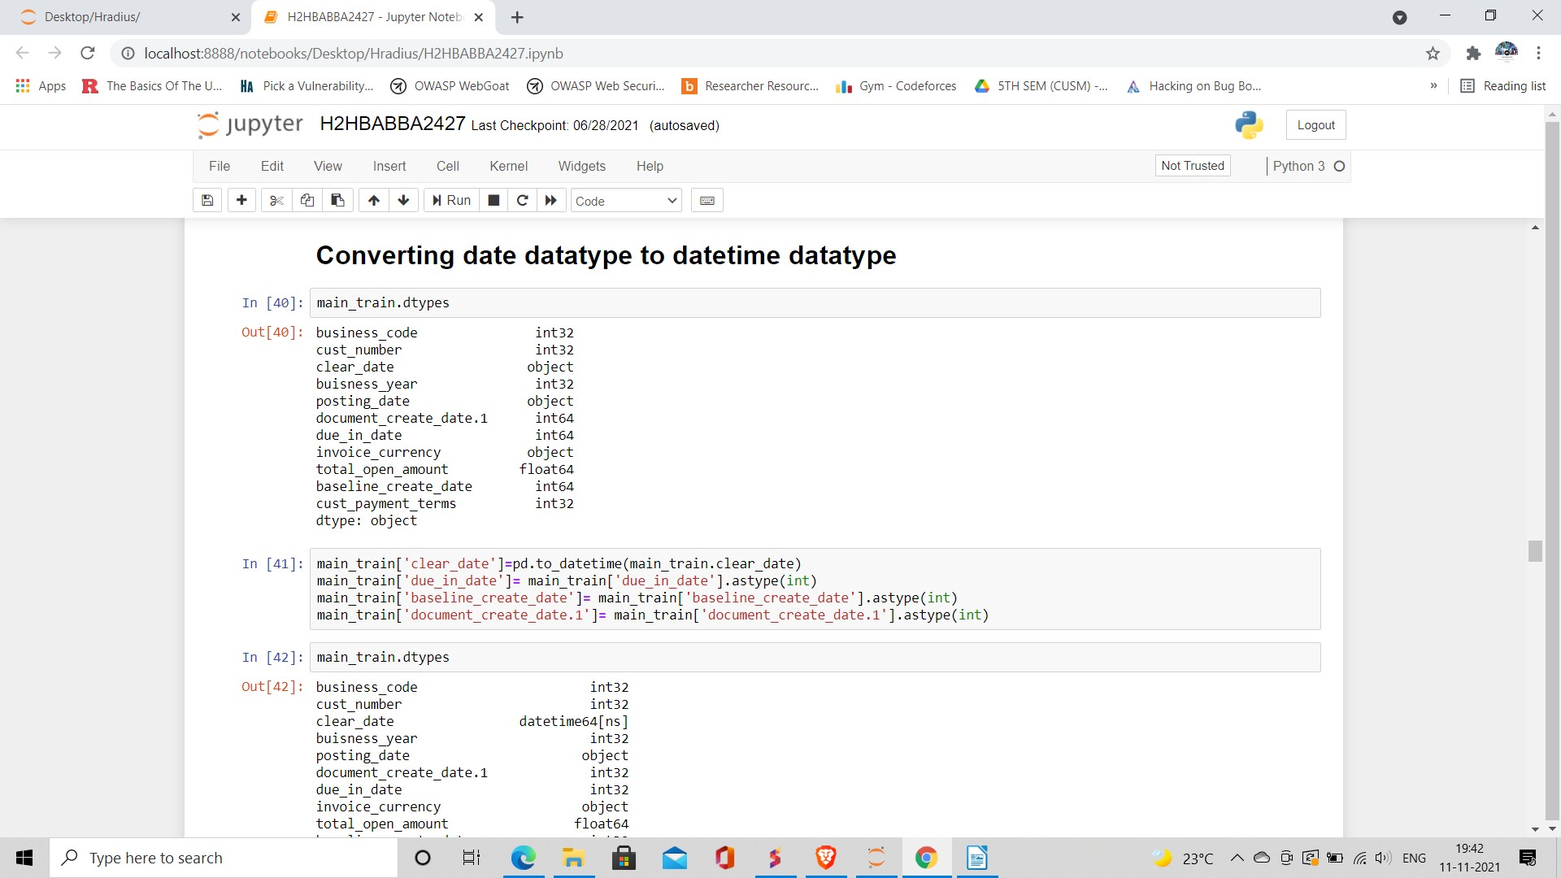

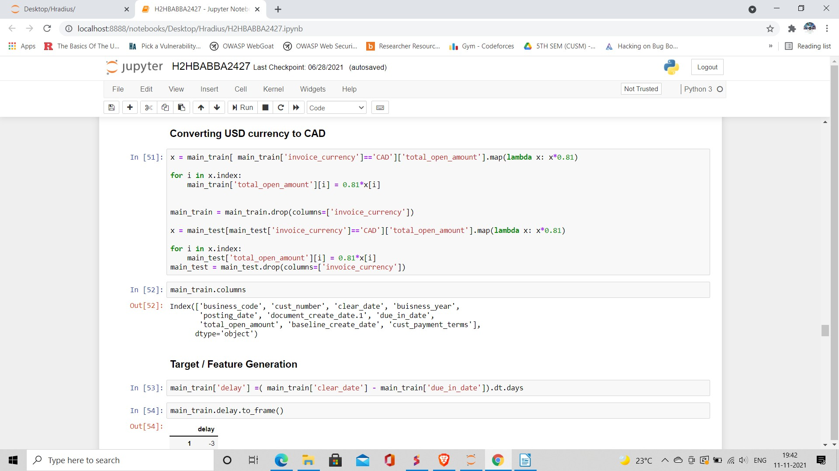

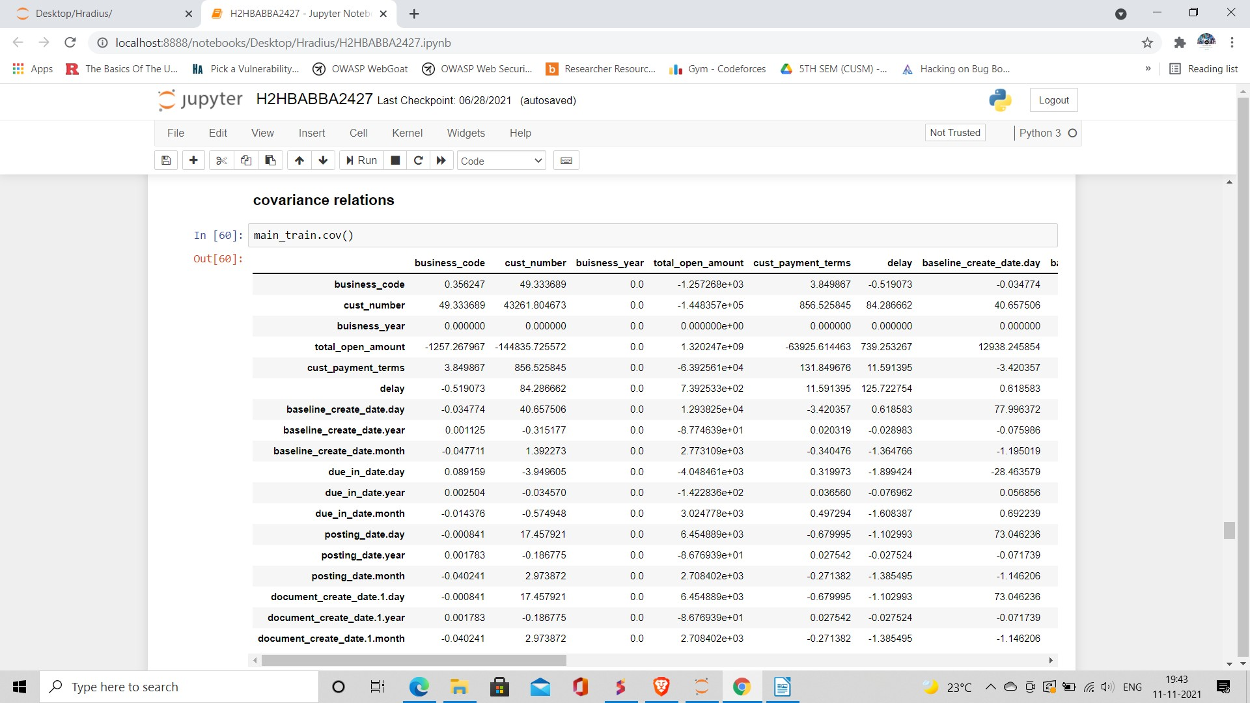

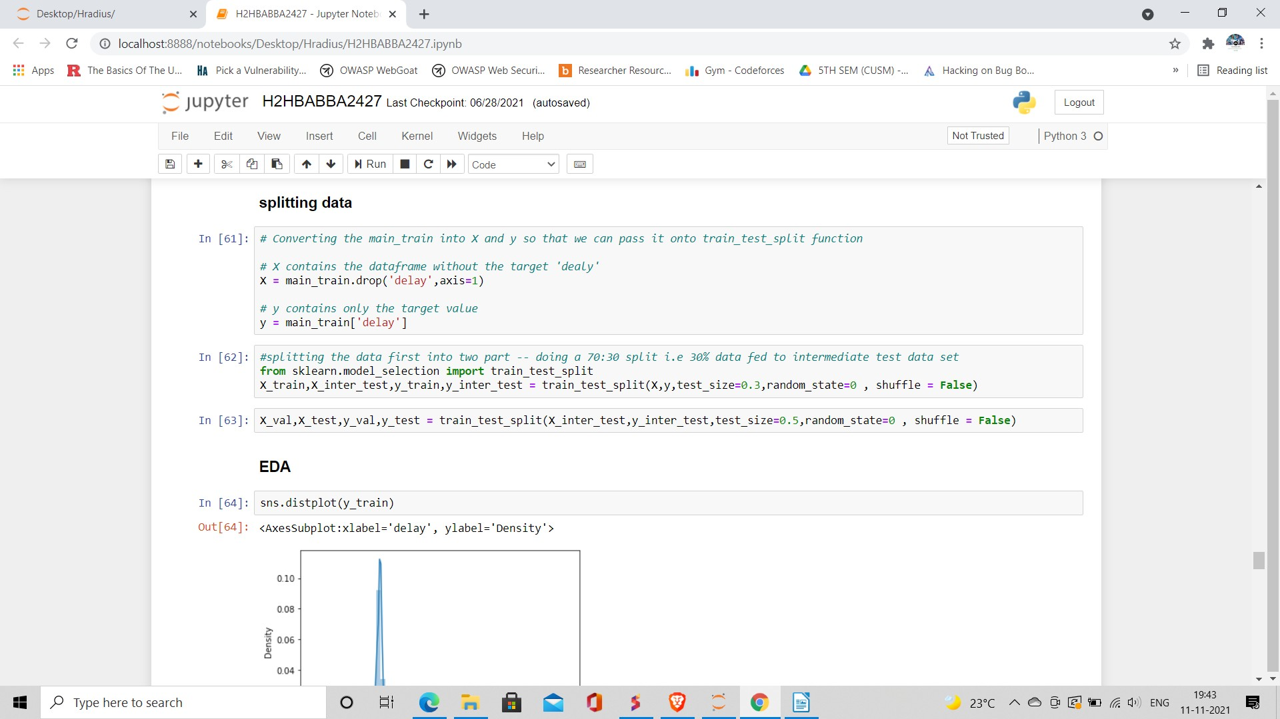

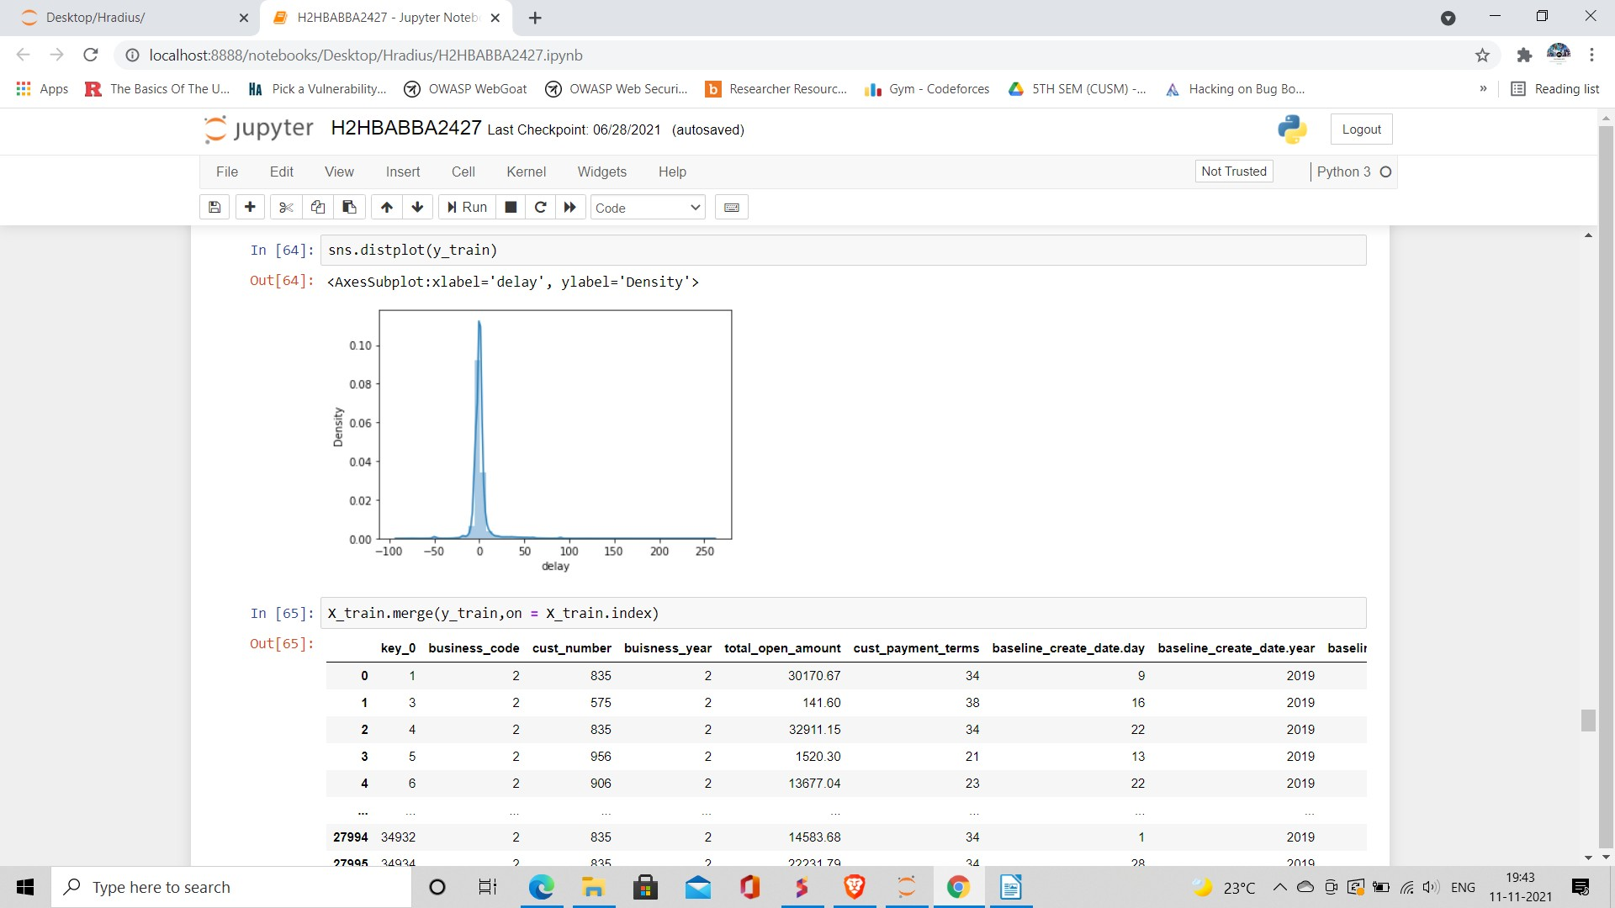

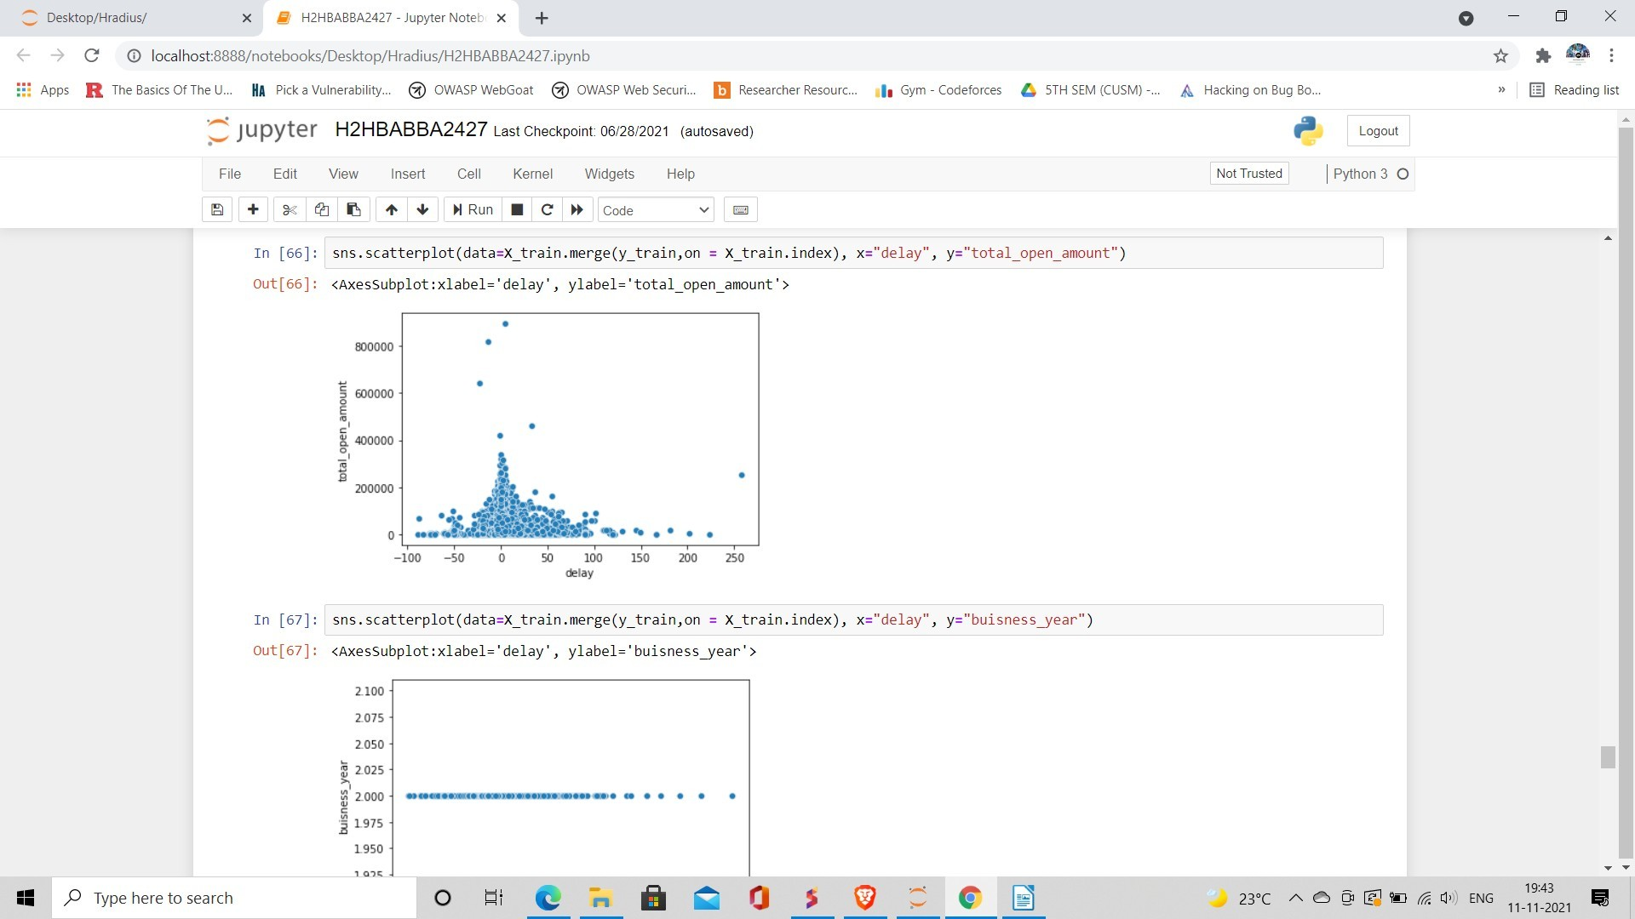

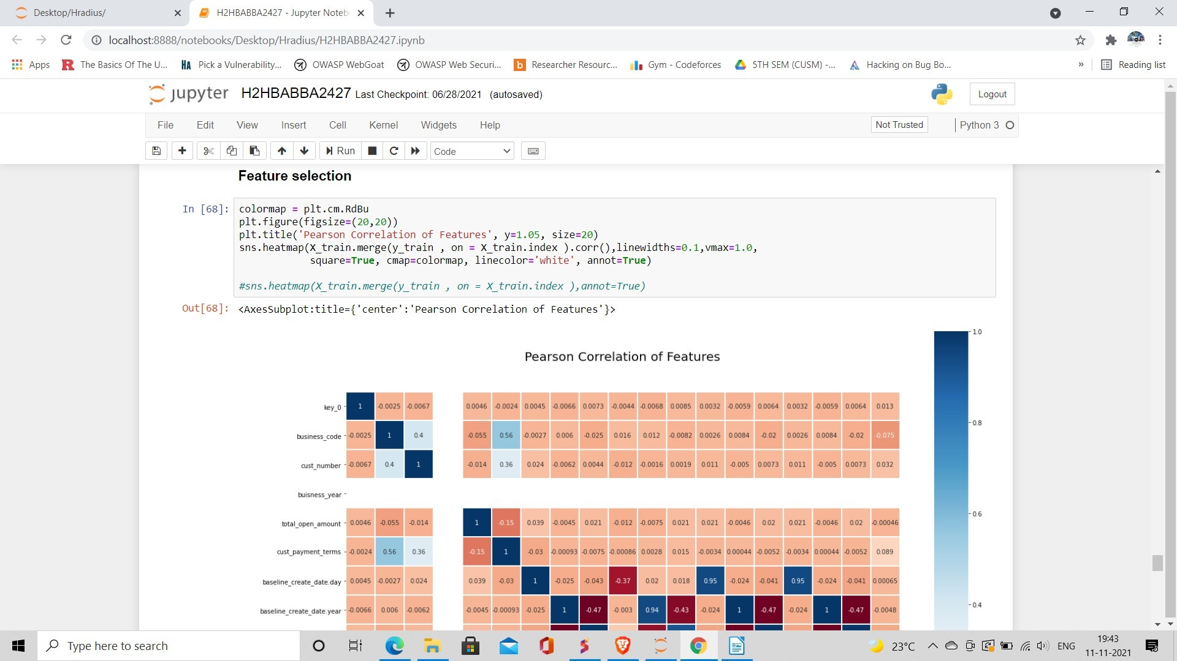

# Application :

1. To develop a tentative payment date prediction model and how to build an interactive dashboard for it.
2. We implemented payment date predictor using the LSTM model.
3. Payment date prediction aims to solve the ambiguity between business and keep the fluidity of market for growth and keep companies form bad investment in companies that are bad with their business.
4. The accurate prediction of Payment date will lead to more profit and not loose money due to delay and prevent you from wasting you effort to get the payment.

# Team Work

Team members of this team Sumit, Ritik and Ravi are working hand in hand for this project.

I (Ritik) am good with deployment of project and with the modules of python used for the prediction and hence taking on the development phase. I have previous experience with ML project deployment.

Sumit – His contribution is regarding the knowledge and working of Credit system market and the requirement of invoice prediction date system to keep balance between B2B business. Gathering data and visualizing it for the practical use.

Ravi - He has collected all the requirement to complete this project under our mentor and analyses all the thing and hence making our documentation part much easier